The User Guide to GBMS Project

Contents:
- Aims of the Project
- Software And Hardware Requirements
- Prerequisites
4. Instructions to the User

- Aims of the Project

- Administrator will be able to use facilities for adding, deleting and updating the database of the students whenever required according to the administration privilege levels.
- The maximum privilege is given to the administrator in order to update the database.
- As the project is user friendly, the user is able to access all the controls and functions of the database.
- A user can maintain all the records and information related to the student, faculty, other activities, accounts and results of the school database.

- Software And Hardware Requirements

- Windows XP/7
- Visual Basics 6.0
- Oracle Server 9i

- Prerequisites

- The user should have the knowledge of basics of computer and handling a database.
- He/she must be well versed with the software features that VB offers.

- User should have the basic knowledge of SQL database.

- Instructions to the User

- Very first step to get it started is to log in with a correct password.
- After logging in, there will be a form containing all the features of the project such as result,add/edit,activities,accounts etc.
- By clicking on the icon as well as on the menu bar respective form will be opened.
- Following functions are available in the project:

- Admin Username and Password

- The project has been given a default User name as “admin” and a password as “pict123” for admin to log into the database
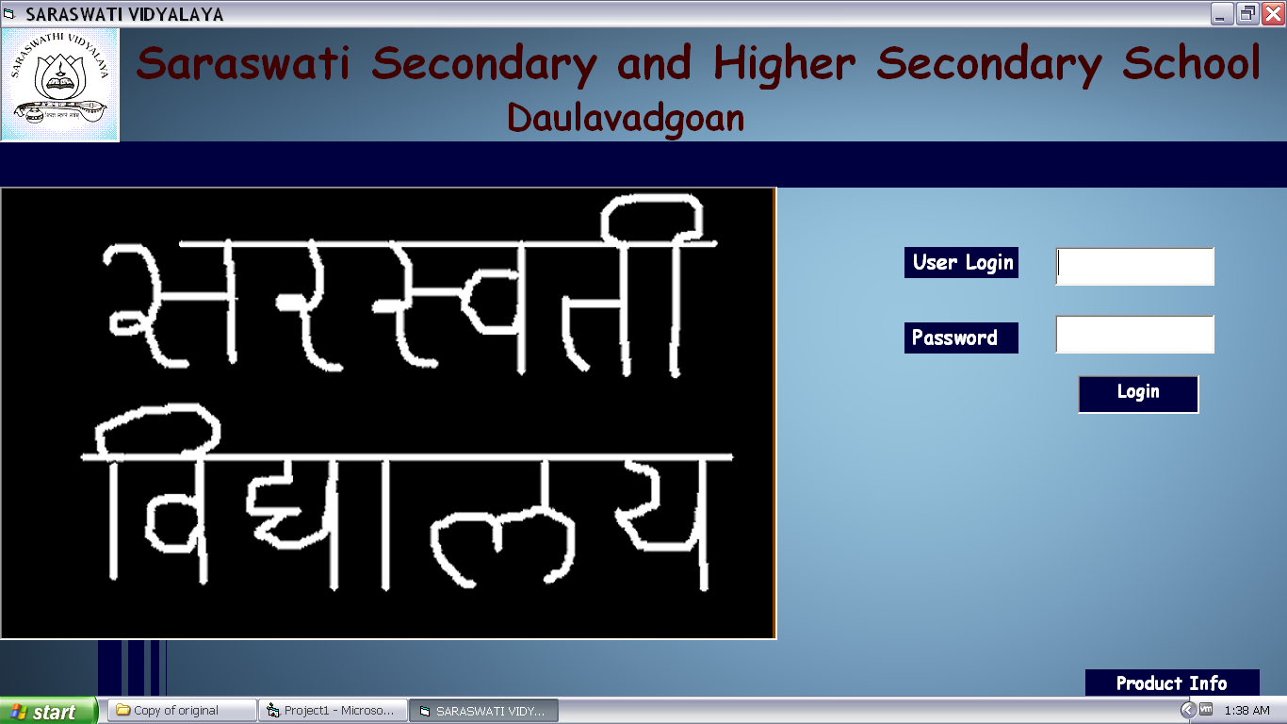

- Add New Student

- User can add new student to the database by entering the details of him/her such as his personal and academic details.

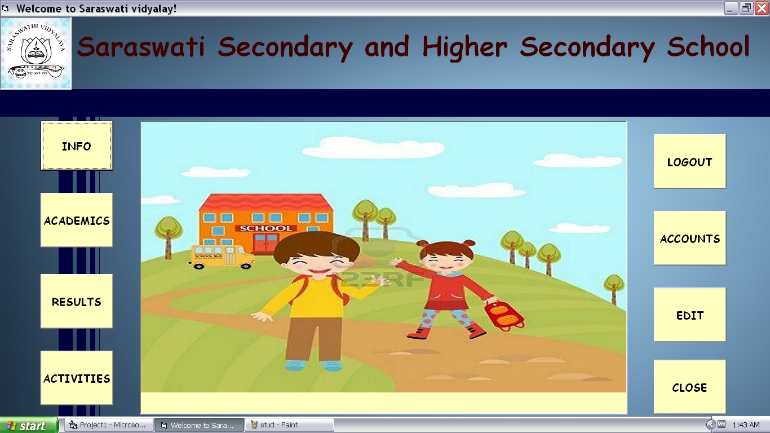

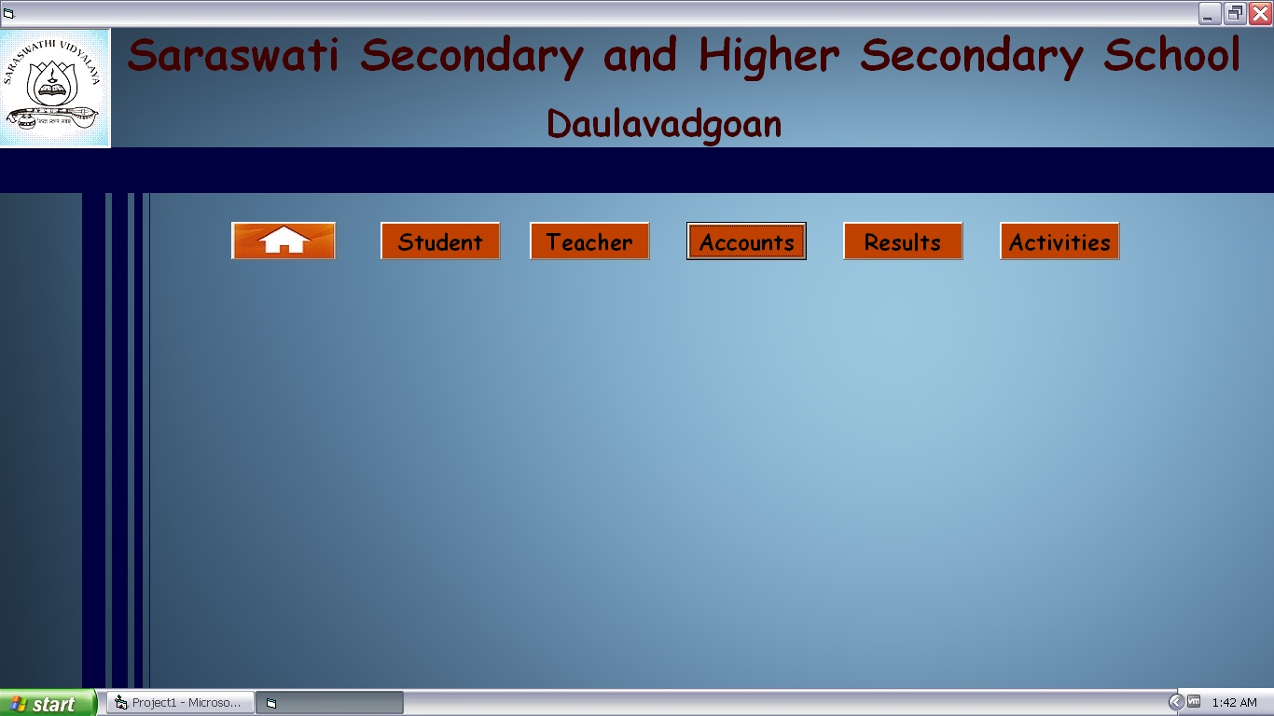

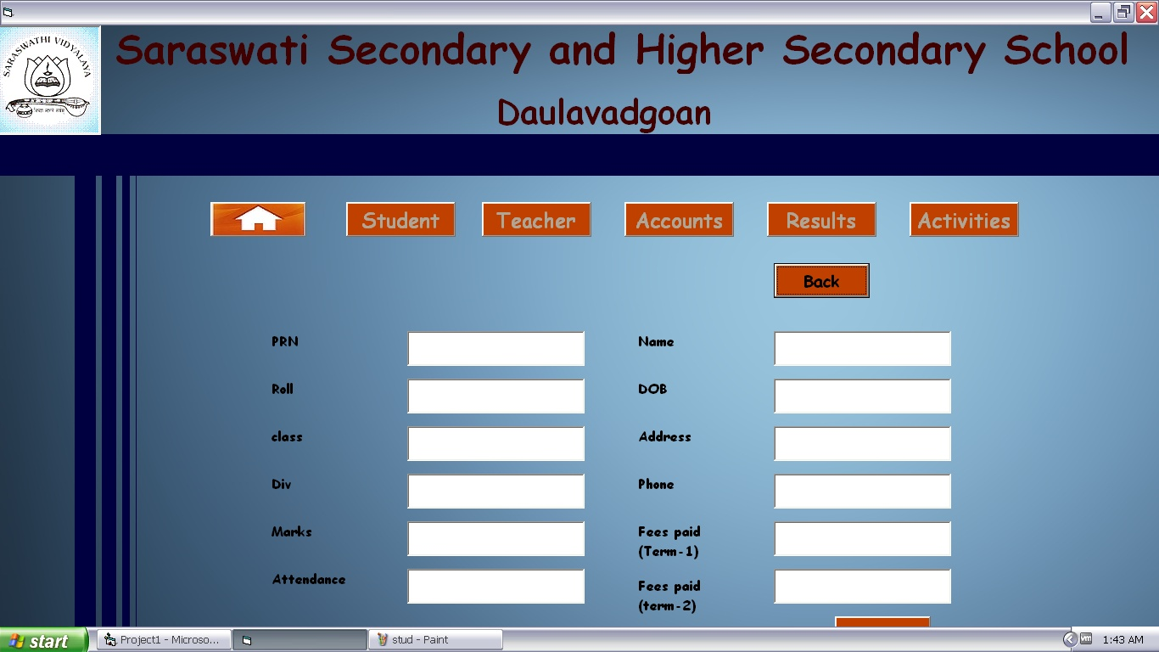

Similarly you reach the other options.......

- Add New Faculty

- User can add new faculty to the database by
entering the personal details, qualification and the academic related details such as the subjects which the teacher is teaching in a respective class.
- Add New Activity

- User can add new activity to the database by
entering the details of the activity such as its name and the members involved in it along with the teacher guardian.

- Displaying the Fee Structure

- The fee is categorized on the following basis .
- Student Wise along with his/her fee dues.
- Class wise fee structure of the students.

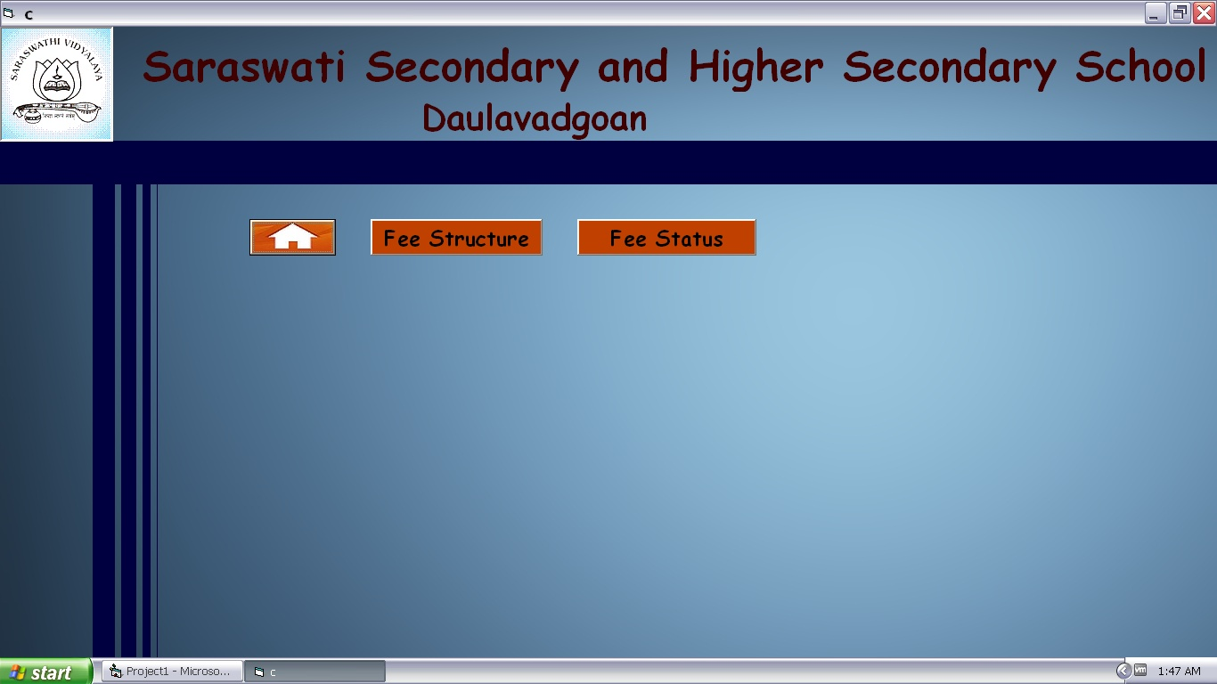
- Displaying the Result of the Students

- User can display the result of the students by searching for his/her permanent registration number or class.
- There is a home button on each form

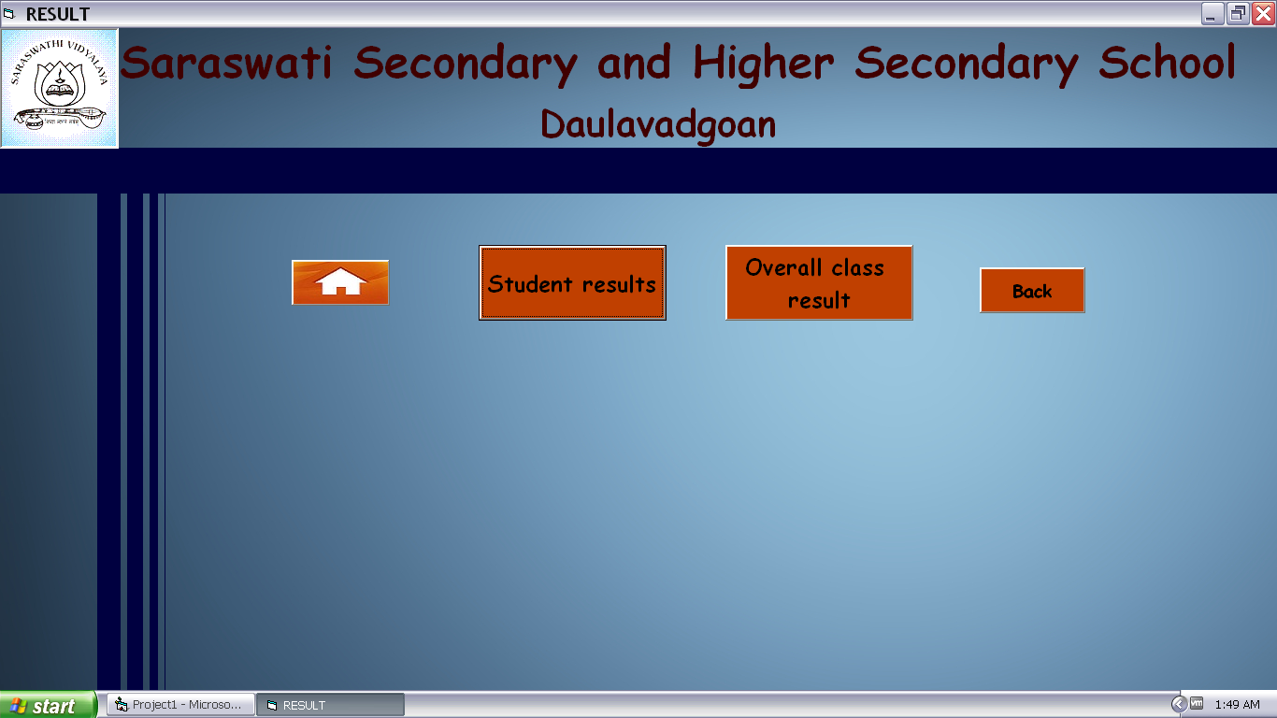

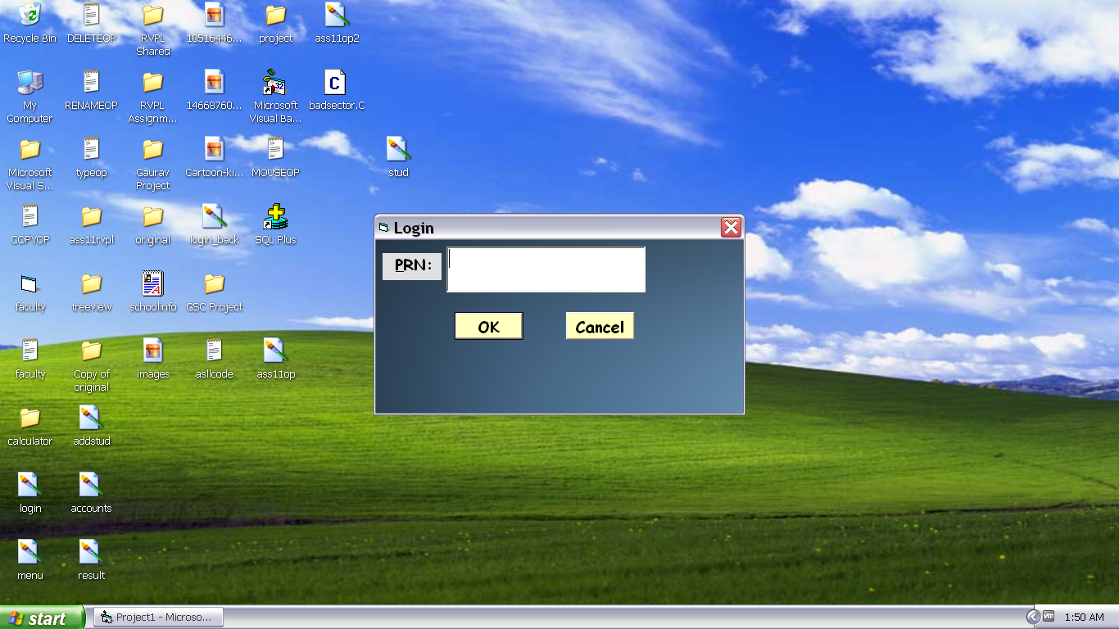

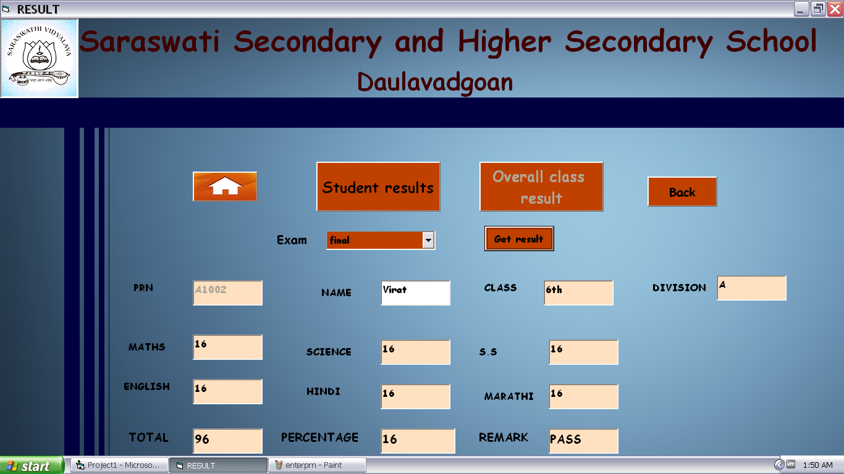

Likewise you can access all other options......

Hope you enjoy the journey........

